ZOMATO Restaurant Analysis


Spreadsheet Project

By: Kumari Shreesty
Submitted to: Newton School

Problem Statement:
You are hired as a consultant data analyst by Zomato, where the team is looking for expansion and opening restaurants. Your task is to come up with strategies/suggestions about opening newer restaurants.

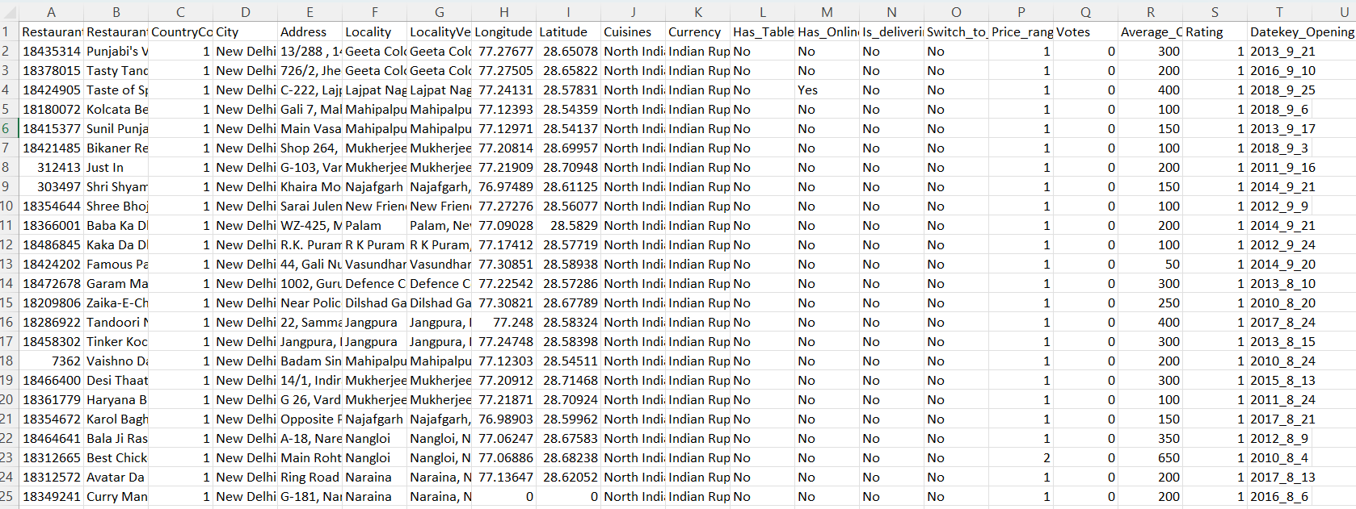

Answer:
First Step is to clean the dataset, for which we will do data preprocessing.

Data Preprocessing:

- Removed duplicates from the dataset.
- Handled missing values from the raw dataset
- The data type of columns is checked to see whether they are of the proper format or not.
- Three new columns are added with the names ‘Customized_Price’, ‘Country_Name’.
- Year is extracted from the Datekey/Opening column in the ‘Year’ column for analysis.
- Converted ‘Avg_cost_og_two’ into Indian National Rupees (INR) in the new column ‘Avg_Cost_Of_two_INR’ for better data analysis.

Objective Questions:

- What is the total no. of tables present in the data?
Answer: There are two tables present in the dataset:
- Raw data of Zomato
- Country description

- What is the total no. of attributes present in the data?
Answer: There are 20 attributes (Columns) present in the dataset.

- How many categorical columns are there in the data? [Search about categorical and continuous data, and try to answer this question]

Answer: A column that contains labels or categories instead of numerical values used for calculation.
There are 11 categorical columns in the raw data. To identify these columns, I used the formula =COUNTA(UNIQUE(range)) for each column.

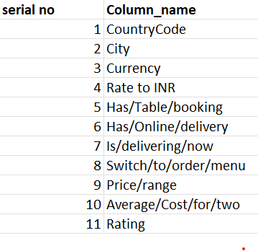

- The data consists of some inconsistent and missing values so ensure that the data used for further analysis is cleaned.

Answer: Methods that are used to clean the data set for analysis are as follows:
- Missing Values:
To find out the missing values, I have used the filter function in each column and searched for blanks.
In the cuisines column, I have found 9 missing data. All the missing data are from the United States of America. After analyzing the USA cuisines, most of the items are American, so I used the formula
=IF (j2=””,” American”, j2).
to fill out the missing values with the approx. data.
- To make data more consistent, I have extracted the year from the Datekey/Opening column so it can be used for better analysis. Formula I have used to extract the year is
=YEAR (serial_number)
- To remove the duplicates, I have selected the whole data with Ctrl A, then gone to the data tab and then clicked on Remove Duplicates. After clicking, a pop-up appears displaying "No duplicate records found."
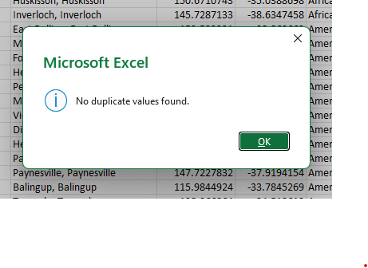
- Change of currency to INR:
This raw dataset contains restaurants from different countries using different currencies. To allow comparative cost analysis. All costs values converted to INR.
I have used a reference table to convert the other countries' prices to the Indian price rate.
I’ve converted the Average cost for two from various countries into a common currency, the Indian Rupee, to enable consistent comparison in data analysis.
- I’ve hidden two columns, the first one is Locality verbose because it has repetitive data, and second one is address because it is too detailed and cannot be used in analysis.
- Using the LookUp functions, fill up the countries in the original data using the country code.

Answer: For country-wise analysis, we need the country name in our raw data. For that, I’ve created a column named Country_name and filled the column using the VLOOKUP function using the country code present in the raw data, and extracted the lookup value from the country description table. The formula that is used:
=VLOOKUP ($C2,'country description'!$A$1:$B$16,2,FALSE)
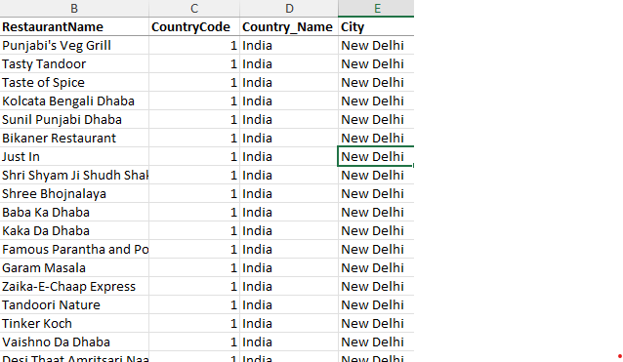

- Create a table to represent the number of restaurants opened in each country.

Answer: To find the number of restaurants opened in each country, I have used a pivot table in the worksheet named “Objective Answer” in the Excel sheet.
To create the pivot table, I have used the country_name in rows and the restaurant_id in values, and set the value to count to show the count of restaurants opened in each country.

Below is the pivot table and chart screenshot:

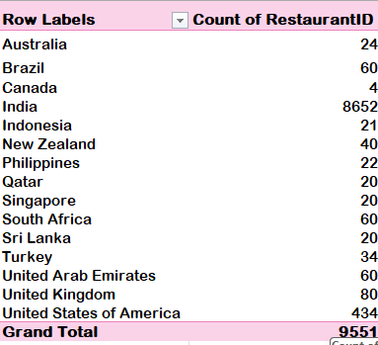
country-wise restaurant distribution.

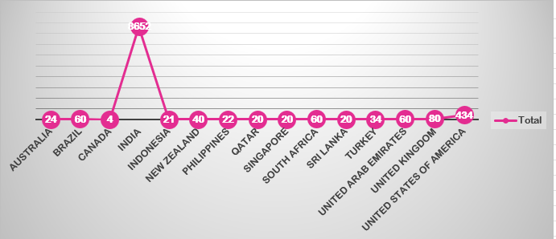
The chart shows that India has the highest number of restaurants, indicating a highly competitive market.

- Also, the management wants to look at the number of restaurants opened each year, so provide them with something here.

Answer: To find the number of restaurants opened each year, I have created a pivot table.
To create the pivot table, I have used the Year column in rows and the restaurant_id in values, and set the value to count to show the count of restaurants opened each year.
Below is the pivot table and chart screenshot:

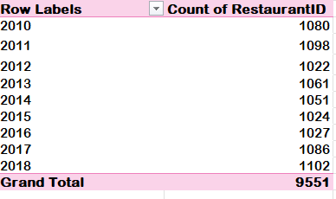
yearly restaurant openings.

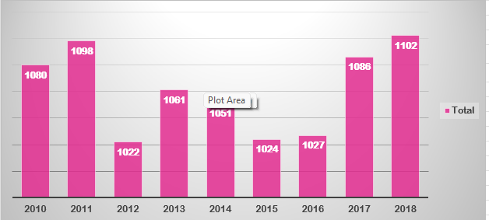
The chart indicates fluctuations in restaurant openings across different years.

- What is the total number of restaurants in India in the price range of 4?

Answer: To find the total number of restaurants in India in the price range of 4, I have used the COUNTIFS function in the raw data provided. The answer can be found in the “Objective Answer” worksheet.

=COUNTIFS ('Raw Data'!$D:$D,"India",'Raw Data'!$S:$S,"=4")
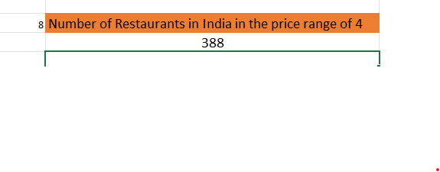
- What is the average number of voters for the restaurants in each country according to the data?

Answer: To find the average number of voters for the restaurants in each country, I have created a pivot table in worksheet “Objective Answer” in the Excel sheet.

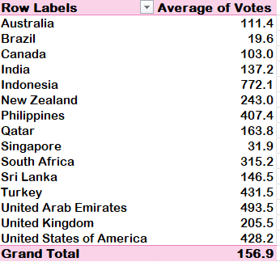
The average votes country-wise.
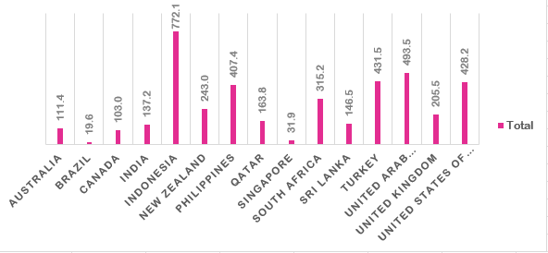
Higher average votes in UAE and Turkey indicate strong customer demand and engagement.

- Calculate the average rating for all the restaurants that have a price_range < 4 and provide online delivery. Use only the “IF” function, Logical Operators, and Aggregation functions to solve this problem. [Note: Don’t use Conditional aggregation in this question.]

Answer: In this question, we have to avoid conditional aggregation. So I have used the IF function with a logical operator to satisfy both the conditions and the aggregate function to find the average.

=AVERAGE(IF(('Raw Data'!S:S<4)*('Raw Data'!P:P="Yes"),'Raw Data'!W:W))

- Using Conditional formatting, highlight the rows of restaurants that are located in the countries or cities that you’ve suggested to the management for opening new restaurants.

Answer: Four factors are being considered before suggesting the countries to the management for opening new restaurants:
- High demand: The country that has a higher number of average votes is being considered. Location with high demand and moderate competition is the best country for suggesting.
- Competition: Competition was analysed by counting the number of restaurants. Locations with moderate competition were preferred, as they provide better opportunities for new businesses.
- Pricing: Pricing was analysed using the price range and average cost for two. Locations with moderate pricing and high demand were preferred, as they provide a balance between affordability and profitability.
- Rating: Ratings were used to measure customer satisfaction. Locations with high demand but lower ratings were preferred, as they indicate an opportunity to provide better quality services.

Based on the analysis of rating, demand (votes), competition, and pricing, the following countries are recommended for opening new restaurants:
- United Arab Emirates
- Turkey
- New Zealand
- Australia
A slightly flexible rating range was considered to include countries with strong demand and growth potential. The United Arab Emirates and Turkey are identified as the best options due to their high demand and balanced competition. New Zealand offers a stable market with moderate demand and manageable competition, while Australia provides a low-risk option with low competition and reasonable pricing.

I have highlighted the countries in the suggested_country sheet using conditional formatting. The formula that I have used is:

=OR(C3="Australia",C3="United Arab Emirates",C3="Turkey",C3=”New Zealand”)

I have done this analysis using a pivot table:
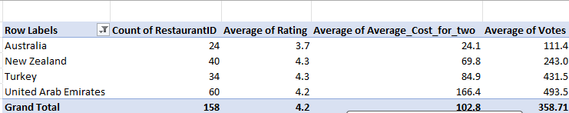
Highlights competition levels across countries.

- Create a new customized price column that consists of the abbreviation/symbol of the currency along with the Average_cost_for_two value. [Use string operations to do this task]

Answer: First of all, I have created a table in another sheet named reference_sheet for taking reference to fill my customized column.
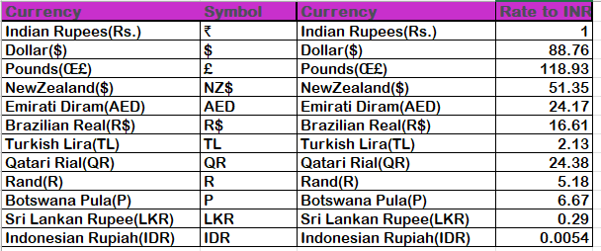
Currency Conversion and Customized Price Analysis
I have created a Currency_Symbol column after the Currency column using the VLOOKUP function:
=VLOOKUP($L2,refrence_sheet!$A$1:$B$13,2,FALSE)
I have created the Rate_to_INR column. In this column, I am extracting the currency rate of different countries in Indian rupees. The formula for this is:
=VLOOKUP($L2,refrence_sheet!$C$1:$D$13,2,FALSE)
Next, I have created a Customized_Price column after the Votes column in this column, I have concatenated the Currency_Symbol and Avg_Cost_for_two to give me the customized price with symbol and price. Formula I have used is:
=CONCAT(M2,"",V2)
Next, I have created an Avg_Cost_for_two_INR column to change the cost of two persons in different countries into Indian rupees for better analysis:
=V2*N2

- How can you create an array formula in Excel or Google Sheets to count the number of restaurants listed that do not offer online delivery, are in the lowest price range, and have an average cost for two people less than or equal to 250 Indian Rupees?

Answer: Three factors have to be considered before answering this question:
- We have to count the number of restaurants listed that do not offer online delivery
- Price range should be the lowest. After analyzing the data, I came to know about the lowest price range, which is equal to 1.
- Avg_Cost_for_two_INR should be less than or equal to 250.

Keeping in mind these three points, I have answered this question in the Objective sheet in Excel using Array Formula:
={SUM(('Raw Data'!P:P= "No")*('Raw Data'!S:S=1)*('Raw Data'!Z:Z <=250))}

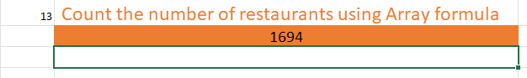
Array Formula Result Analysis

Subjective Questions:

- Suggest a few countries where the team can open newer restaurants with lesser competition. Which visualization/technique will you use here to justify the suggestions?

Answer: To answer this question, I have considered four factors:
- High Demand: The country that has a higher number of average votes is being considered. Location with high demand and moderate competition is the best country for suggesting.
- Competition: Competition was analysed by counting the number of restaurants. Locations with moderate competition were preferred, as they provide better opportunities for new businesses.
- Pricing: Pricing was analysed using the price range and average cost for two. Locations with moderate pricing and high demand were preferred, as they provide a balance between affordability and profitability.
- Rating: Ratings were used to measure customer satisfaction. Locations with high demand but lower ratings were preferred, as they indicate an opportunity to provide better quality services.
Pivot Tables and Pivot Charts were used to compare countries based on restaurant count, average votes, ratings, and average cost for two.
Analysis:
Countries such as India and the United States have a very high number of restaurants, which indicates strong competition. On the other hand, Australia, Turkey, and New Zealand have lower restaurant density, creating better opportunities for expansion.
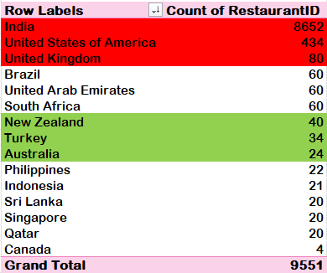
Competition Analysis Across Countries
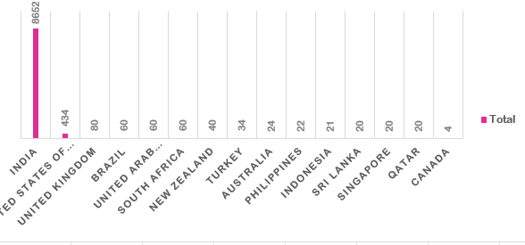
The chart shows that countries with lower restaurant counts provide better expansion opportunities.

The demand analysis shows that the United Arab Emirates and Turkey have high customer engagement based on average votes.

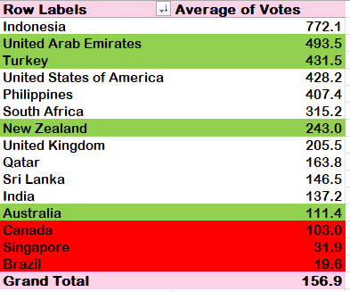
Fig 17: Demand Analysis Based on Average Votes

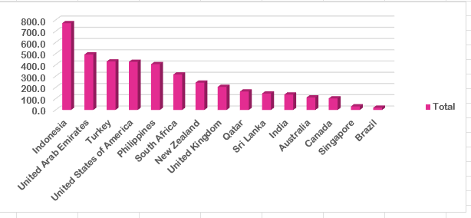

The rating analysis indicates that Turkey, New Zealand, and the UAE maintain ratings above 4.0, showing strong customer satisfaction.

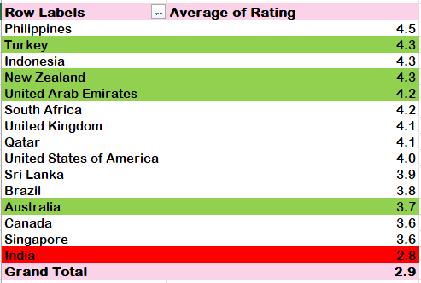
Country-wise Average Rating Analysis

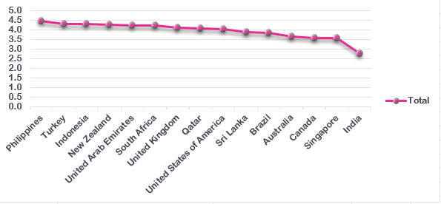

Pricing analysis shows that Turkey, New Zealand, and Australia have affordable average costs for two people, making them suitable for balanced pricing strategies.

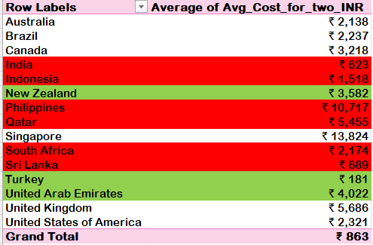
Pricing Analysis Using Average Cost for Two
Final Recommendation:
Based on competition, demand, pricing, and ratings, the most suitable countries for expansion are:
- United Arab Emirates
- Turkey
- New Zealand
- Australia
These countries provide balanced market opportunities with manageable competition and strong customer demand
- Come up with the names of States and cities in the suggested countries suitable for opening restaurants.

Answer: Cities that are being suggested for opening restaurants are as follows:

Analysis and Approach
To identify suitable cities within the recommended countries (The United Arab Emirates, Turkey, New Zealand, and Australia), a detailed city-level analysis was performed.
The following factors were considered:
- Demand (Average Votes) → Indicates customer engagement
- Competition (Count of Restaurants) → Indicates market saturation
- Rating → Indicates service quality and improvement scope
- Pricing (Average Cost for Two) → Indicates affordability
Pivot Tables were used to analyze data at the city level, and cities were shortlisted based on:
- High or moderate demand
- Manageable competition
- Good or moderate ratings
- Reasonable pricing

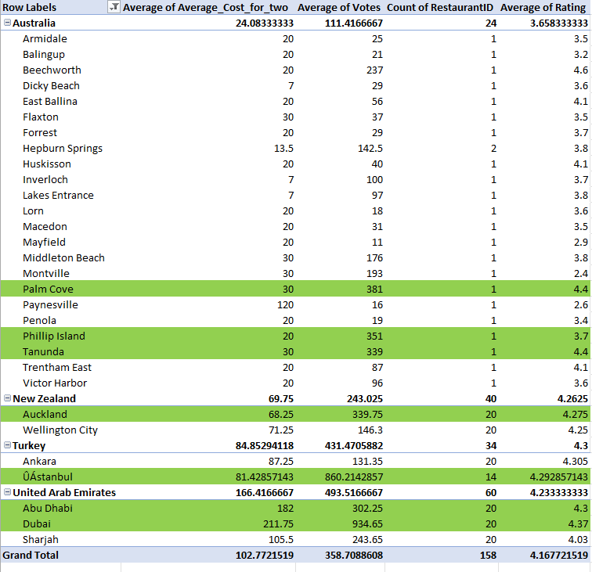
Suggested Cities for Restaurant Expansion

Suggested Cities:
According to the analysis, the suggested cities are:
a) Australia
- Palm Cove
- Phillip Island
- Tanunda
b) New Zealand
- Auckland
c) Turkey
- Istanbul
d) United Arab Emirates
- Dubai
- Abu Dhabi
Recommendations:
1. Australia: Focus on Low Competition Markets
Australian cities such as Palm Cove, Phillip Island, and Tanunda have very low competition, with only one restaurant currently available in the dataset. These cities also maintain good customer demand and ratings.
Recommendations:
- Open casual dining or tourist-focused restaurants.
- Focus on quality service and unique dining experiences.
- Use local and regional cuisine concepts to attract visitors.
2. New Zealand (Auckland): Stable Market Opportunity
Auckland shows stable customer engagement, balanced competition, and strong ratings, making it suitable for restaurant expansion.
Recommendations:
- Mid-range family dining and café concepts can perform well.
- Focus on customer experience and online engagement.
- Maintain moderate pricing strategies.
3. Turkey (Istanbul): High Demand with Lower Competition
Istanbul has very high average votes along with comparatively lower competition, making it one of the strongest expansion opportunities.
Recommendations:
- Focus on premium dining and fusion cuisine concepts.
- Provide online delivery and table booking services.
- Target urban customers and tourists.
4. United Arab Emirates (Dubai & Abu Dhabi): Premium Market Potential
Dubai and Abu Dhabi show very high customer demand and strong ratings. These cities provide strong revenue opportunities because of higher customer spending capacity.
Recommendations:
- Focus on premium dining and international cuisine.
- Maintain high-quality ambience and customer service.
- Use digital marketing and online delivery platforms for wider reach.
- According to the countries you suggested, what is the current quality regarding ratings for restaurants that are open there?
Answer:
Approach:
- To answer this question, the Pivot Table approach was used again.
- The analysis mainly focused on Average Rating as the key factor to understand restaurant quality in the recommended countries.
- Country was taken in Rows and Average of Rating was taken in Values as Average in the worksheet named ‘Subjective Question 2’.
- Additional factors such as customer demand and competition were also observed from the Pivot Table for a better understanding of market quality.

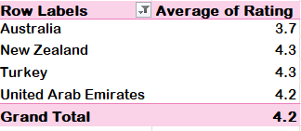
Image From ‘Subjective Question 3 and 4’ Worksheet in Excel Sheet.

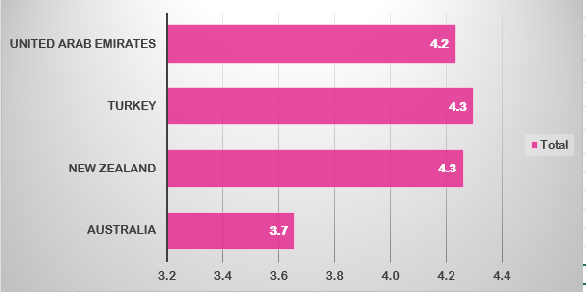
Visualisation Technique: ‘Horizontal Bar Chart’

Analysis and Recommendations:
By placing Countries in Rows and Average Rating in Values as Average, the following observations were identified:
• The selected countries maintain average ratings between 4.2 to 4.3, which indicates strong restaurant quality and customer satisfaction.
• Australia has an average rating of around 3.7, which is comparatively lower than the other selected countries, showing opportunities for service improvement and better dining experiences.
• New Zealand and Turkey maintain ratings above 4.2, indicating stable restaurant quality and positive customer feedback.
• The United Arab Emirates also maintains strong ratings along with high customer demand, showing a premium dining market with good customer engagement.
• The small variation in ratings among the selected countries indicates that all these markets possess good restaurant quality and stable customer satisfaction levels.
• Countries with ratings above 4.0 provide better opportunities for opening new restaurants because customers already show positive dining behaviour and market acceptance.

- Also, what is the current expenditure on food in the suggested countries, so we can keep our financial expenditure in control?
Answer:
Approach:
• For calculating the current expenditure and understanding financial control, the Pivot Table
approach was used.
• Country was taken in Rows, and the following fields were taken in Values:
- Average Cost for Two in INR
- Count of Restaurants
• The analysis was performed in the worksheet named ‘Subjective Question 3 and 4’.
• To estimate the expenditure for each country, a separate table was created using the formula:
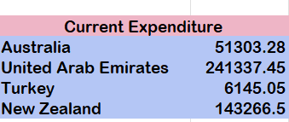
GETPIVOTDATA formula was used to extract the expenditure values for each country from the Pivot Table.
=GETPIVOTDATA("Average of Avg_Cost_for_two_INR",$N$4,"Country_Name","Australia")*GETPIVOTDATA("Count of RestaurantID",$N$4,"Country_Name","Australia")
The same formula was applied for all the recommended countries.
Visualisation Technique:
• ‘Pie Chart’ was used to compare expenditure distribution across the suggested countries.
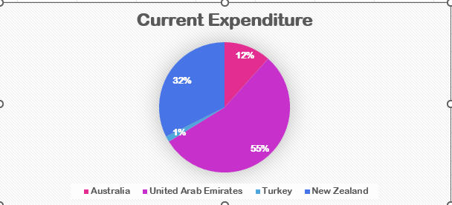
Analysis of Expenditure:
The expenditure analysis shows major differences among the suggested countries.
• The United Arab Emirates has the highest expenditure of approximately ₹2.41 lakh, contributing around 55% of the total expenditure. This indicates a premium dining market with higher customer spending capacity.
• New Zealand contributes around 32% of the total expenditure with approximately ₹1.43 lakh, showing balanced pricing and stable customer demand.
• Australia contributes around 12% of the total expenditure with approximately ₹51,303, indicating moderate operational and dining costs.
• Turkey has the lowest expenditure of approximately ₹6,145, contributing only around 1% of the total expenditure, making it a highly cost-effective market.

• For better comparison, a Combo Chart of Count of Restaurants vs Average Cost for Two in INR was also used.
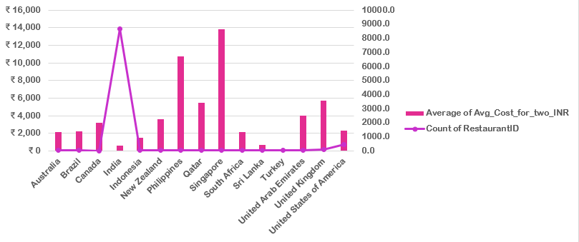
Image From ‘Subjective Question 3and 4’ Worksheet in Excel Sheet

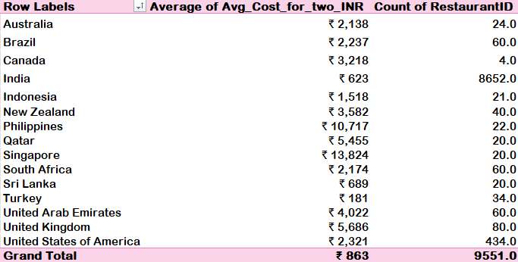
Pricing Analysis Using Average Cost for Two

Insights:
1. High Spending Market
• The UAE represents the highest financial expenditure because of premium pricing and strong customer spending behaviour.
2. Balanced Market Opportunity
• New Zealand provides balanced expenditure with stable customer engagement and moderate pricing opportunities.
3. Low Financial Risk
• Turkey shows very low expenditure, making it suitable for expansion with lower operational risk and affordable pricing strategies.
4. Moderate Pricing Structure
• Australia maintains moderate expenditure levels, providing opportunities for controlled financial planning and stable market entry.

Recommendations:
1. Premium Positioning in UAE
Focus on premium dining experiences, ambience, and high-quality customer service to justify higher pricing.
2. Cost-Effective Expansion in Turkey
Use affordable pricing and operational strategies to maximize profitability in Turkey.
3. Balanced Investment Strategy
Maintain moderate pricing and customer-focused services in Australia and New Zealand to achieve stable growth and customer satisfaction.

- Come up with the names of restaurants from the recommended states that are our biggest competitors and also those that are rated in the lower brackets, i.e. 1-2 or 2-3.
Answer:
Approach:
• Used the Pivot Table concept to analyse competitors and low-rated restaurants.
• Countries and Restaurant Names were taken in Rows, while Average of Ratings and Average of Votes were taken in Values in the worksheet named ‘Subjective Answer 5.’
• Restaurants with high ratings and strong customer engagement were considered major competitors.
• Restaurants having ratings between 1 and 3 were identified as low-rated restaurants for quality analysis.
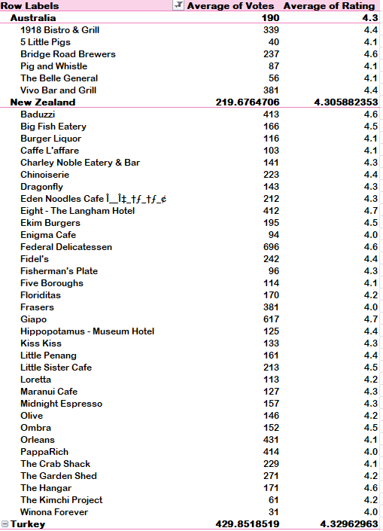
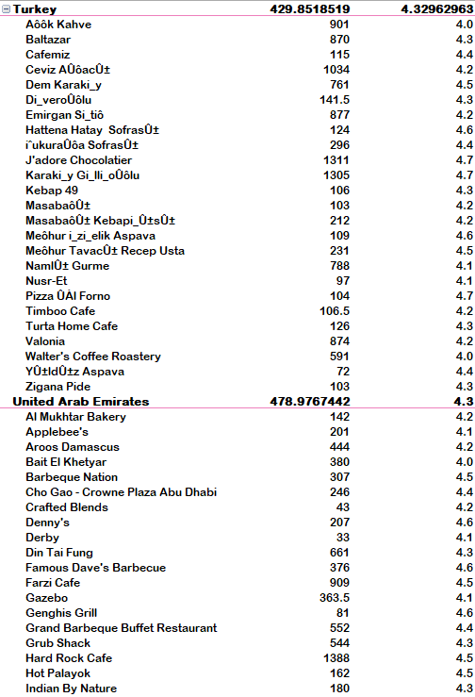
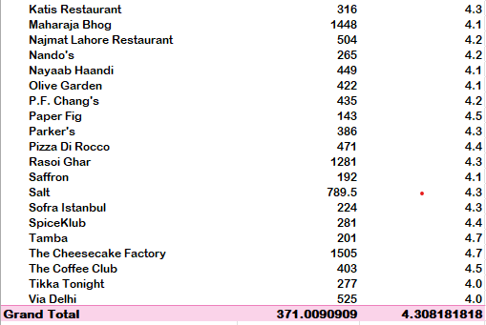
Competitor Analysis in Recommended Countries
Image From ‘Subjective Answer 5.’ Worksheet in Excel Sheet

Insights about Competitors Available
The analysis highlights several high-performing restaurants in Australia, New Zealand, Turkey, and the United Arab Emirates. These restaurants maintain ratings above 4 and also attract strong customer engagement through higher vote counts.
Key Competitors Identified
Australia
• Vivo Bar and Grill and Bridge Road Brewers are strong competitors because of their high ratings and positive customer feedback.
• These restaurants maintain good customer satisfaction and strong dining experiences.
New Zealand
• Giapo and Federal Delicatessen are among the strongest competitors in New Zealand because of excellent ratings and high popularity among customers.
• These restaurants show stable market presence and strong customer engagement.
Turkey
• J'adore Chocolatier and Karaköy Güllüoğlu are major competitors because of high customer ratings and strong customer loyalty.
• Their popularity makes them strong benchmarks for service quality and customer satisfaction.
United Arab Emirates
• The Cheesecake Factory and Hard Rock Cafe are major competitors because of their very high vote counts and strong brand presence.
• These restaurants maintain premium dining experiences and strong customer engagement.

Overall Competitor Insights
• These restaurants demonstrate strong customer satisfaction and market popularity.
• High ratings along with large vote counts indicate consistent food quality, service standards, and customer loyalty.
• These competitors act as strong benchmarks for restaurant quality and customer experience in their respective markets.
Insights about Restaurants Rated in Lower Bracket
Restaurants having ratings between 1 and 3 were considered low-rated restaurants.
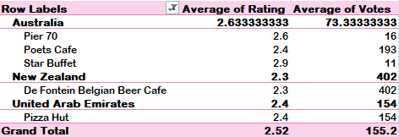
Analysis of Low-Rated Restaurants
The analysis shows that restaurants with ratings between 1 and 3 generally struggle with customer satisfaction, service quality, and dining experience.

Market-Specific Observations
Australia
• Some restaurants maintain ratings between 2.4 and 2.9, indicating inconsistent service quality and customer experience.
• Moderate vote counts show that customers visit these restaurants but are not fully satisfied with the service quality.
Turkey and UAE
• Few restaurants show lower ratings despite maintaining customer engagement, indicating operational and service improvement opportunities.

High Engagement but Lower Satisfaction
• Some restaurants continue receiving customer visits and votes despite low ratings.
• This indicates that visibility and customer traffic alone are not enough to maintain positive customer satisfaction.
• Service quality, food consistency, and customer experience remain important factors.

Recommendations on Low-Rated Restaurants
1. Improve Service Quality
• Restaurants with ratings between 1 and 3 should improve food quality, customer service, and dining experience.
2. Staff Training and Operational Improvement
• Restaurants receiving high customer traffic but low ratings should focus on staff training, menu improvement, and faster customer service.
3. Focus on Customer Feedback
• Negative reviews and customer complaints should be monitored regularly to identify major operational issues.
4. Promote High-Quality Restaurants
• Restaurants with ratings above 4 should be promoted more actively because they reflect strong customer satisfaction and stable service quality.

- Which cuisines should we focus on in the newer restaurants to get better feedback? Does the choice of cuisines affect the restaurant ratings?

Answer:

Approach

To analyse the factors influencing cuisine preferences and restaurant ratings, the Pivot Table and Chart visualisation approach was used.
• A Line Chart was created using Pivot Table data in the worksheet named ‘Subjective Answer 6’.
• Country and Cuisines were taken in Rows, while Average of Rating was taken in Values as Average.
• The analysis was mainly focused on identifying cuisines that receive higher customer ratings across different countries.

Visualisation Technique:
• ‘Line Chart’ was used to compare cuisine ratings across different countries.

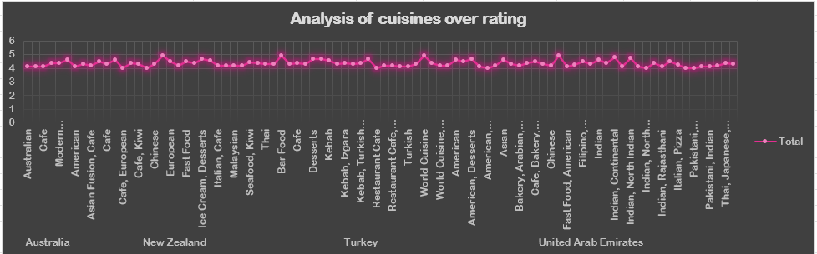
Cuisine Rating Analysis
Image From ‘Subjective Answer 6’ Worksheet in Excel Sheet

Analysis and Insights:

• The chart shows that cuisine preference varies across countries and directly affects restaurant ratings and customer satisfaction.

• In Australia, customers show strong preference towards Pizza, Bar Food, Mediterranean cuisine, and Modern Australian dishes.

• In New Zealand, café-style dining and desserts maintain good customer ratings and engagement.

• Turkey shows strong customer preference for Kebabs, Turkish cuisine, and desserts.

• In the United Arab Emirates, Indian cuisine, Fast Food, American cuisine, and Bakery items receive consistently high ratings.
• The analysis also shows that cuisines such as Desserts, Italian, Pizza, Indian, Seafood, and Mediterranean cuisine maintain stable ratings across multiple countries.

• Cuisine type strongly influences customer satisfaction because customers generally prefer cuisines that match local taste preferences and dining trends.

Top 10 Cuisine Analysis:

To gain better insights into the highest-performing cuisines, a separate Top 10 Cuisine analysis was performed.

‘Column Chart’ was used for visualising the most popular and highly rated cuisines.

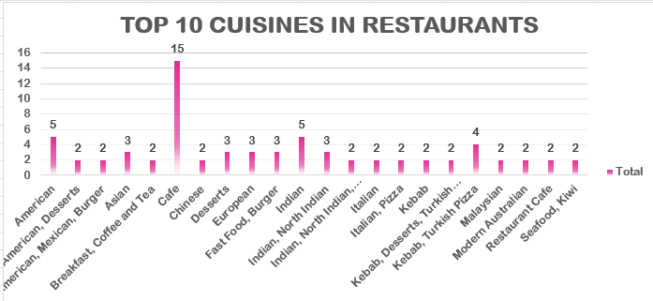

Top Recommended Cuisines Analysis
Image From ‘Subjective Answer 6’ Worksheet in Excel Sheet

Recommendations:

1. Focus on High-Rated Cuisines
• Restaurants should focus on cuisines such as Desserts, Pizza, Italian, Indian, Seafood, and Mediterranean cuisine because these cuisines consistently receive strong customer ratings.

2. Use Local Cuisine Preferences
• New restaurants should prioritize cuisines that match local customer preferences to improve customer satisfaction and market acceptance.

3. Introduce Modern Food Trends
• Introducing modern food concepts such as healthy meals, fusion cuisine, and premium café experiences can attract a wider customer base.

4. Maintain Food Quality and Consistency
• Since cuisine choice strongly affects restaurant ratings, maintaining food quality, presentation, and customer service is essential for positive feedback.

- According to our current data, should we go for online delivery and table booking? Does that affect the customer’s ratings?

Answer:
Approach:
• To analyse whether online delivery and table booking services affect customer ratings, the availability of these facilities was checked in the suggested countries.
• A separate table was created in the worksheet named ‘Subjective Answer 6’.
• Country, Online Delivery, and Table Booking columns were taken into consideration for the analysis.
• COUNTIFS formulas were used to calculate the availability of online delivery and table booking services in the selected countries.

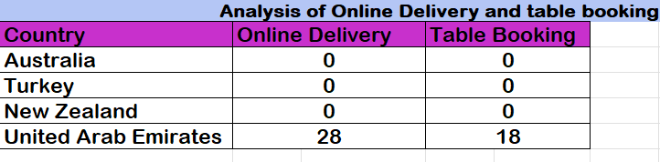
=COUNTIFS('Raw Data'!N:N,"Yes",'Raw Data'!D:D,"Australia")
=COUNTIFS('Raw Data'!M:M,"Yes",'Raw Data'!D:D,"Australia")
Similar formulas were applied for Turkey, New Zealand, and United Arab Emirates.
The analysis shows that Australia, Turkey, and New Zealand currently do not provide online delivery and table booking facilities in the selected dataset.
• The United Arab Emirates is the only country among the selected countries that provides both facilities:
- 28 restaurants provide Online Delivery
- 18 restaurants provide Table Booking
• This indicates that the UAE market is more digitally developed and customer-focused compared to the other selected countries.
• The availability of these services in the UAE may also contribute to better customer convenience, stronger engagement, and higher restaurant ratings.

Visualisation Technique:
• ‘Pie Chart’ was used to compare the availability of online delivery and table booking services across the selected countries.
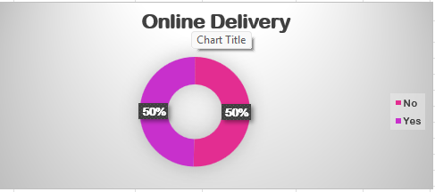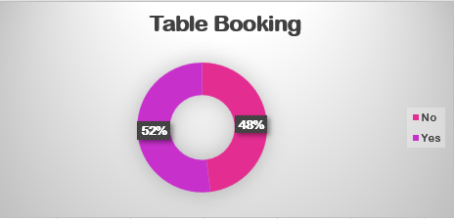
Online Delivery and Table Booking Analysis
Image From ‘Subjective Answer 7’ Worksheet in Excel Sheet
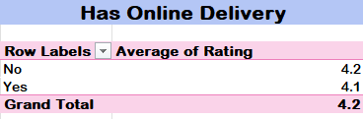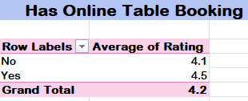

Pivot Tables were also used to compare the average ratings of restaurants providing online delivery and table booking services.
• ‘Has Table Booking’ and ‘Has Online Delivery’ were taken in Rows, while the Average of Rating was taken in Values as Average.
• Separate Pivot Tables were created for both facilities to obtain a clearer comparison.

Insights:
• Countries offering online delivery and table booking services generally show better customer convenience and stronger market competitiveness.
• The UAE already has strong digital dining infrastructure, which gives restaurants a competitive advantage.
• Australia, Turkey, and New Zealand still have opportunities to improve digital services because the absence of these facilities creates a market gap.
• Online delivery and table booking services can help restaurants increase customer satisfaction, accessibility, and operational efficiency.

Suggestions:
1. Introduce Online Delivery Services
• Restaurants in Australia, Turkey, and New Zealand should introduce online delivery platforms to improve customer convenience and increase reach.
2. Implement Table Booking Facilities
• Table booking services can help improve customer experience by reducing waiting time and providing better dining management.
3. Use Digital Platforms for Growth
• Restaurants should use online ordering and reservation systems to improve visibility, customer engagement, and operational efficiency.
Does Online Delivery and Table Booking Affect Customer Ratings?
• Based on the current data analysis, restaurants providing online delivery and table booking facilities generally receive better customer engagement and higher ratings.
• The United Arab Emirates, which has restaurants offering these facilities, also shows strong customer demand and good average ratings compared to other selected countries.
• Online delivery improves customer convenience and accessibility, while table booking enhances dining management and customer experience.
• These facilities help restaurants attract more customers, increase customer satisfaction, and improve overall service quality perception.
• Therefore, the analysis indicates that online delivery and table booking services positively affect customer ratings and market performance.

- Should the team keep the rate of cuisines higher? Will that affect the feedback? According to our data, are the rates of cuisines and ratings correlated?

Answer:
Approach:
• A Pivot Table was created ‘Subjective Answer 8” in the Excel worksheet.
• The Pivot Table was filtered for the recommended countries:
- Australia
- Turkey
- New Zealand
- United Arab Emirates
• Cuisine Types were taken in Rows, while:
- Average Rating
- Average Cost for Two in INR
were taken in Values as Average.
• A Scatter Plot was created to analyse the relationship between cuisine ratings and average cost for two people.
• Additionally, the CORREL function was used to measure the correlation between ratings and average cost in INR.
$$r=CORREL(R:R,S:S)$$

Visualisation Technique:
• A ‘Scatter Plot’ was used to analyse the relationship between cuisine ratings and average cost for two people.
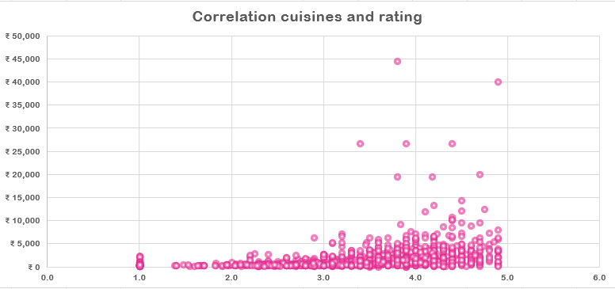
Correlation Between Cuisine Ratings and Average Cost for Two
Image From ‘Subjective answer 9’ Worksheet in Excel Sheet

Analysis and Insights:
Relationship Between Cuisine Ratings and Average Cost
• The Scatter Plot shows a positive relationship between restaurant ratings and average cost for two people.
• As restaurant ratings increase, the average dining cost also tends to increase.
• Most restaurants with ratings above 3.5 show higher pricing compared to restaurants with lower ratings.
• Restaurants with ratings between 4 and 5 generally fall into moderate-to-high price ranges, indicating that customers are willing to pay more for better food quality and dining experience.
• Some restaurants with very high pricing also maintain strong ratings, showing that premium dining experiences attract positive customer feedback.
• The graph also contains a few lower-cost restaurants with good ratings, which indicates that affordable restaurants can also achieve customer satisfaction when service and food quality are maintained properly.
• The correlation analysis confirms a positive relationship between cuisine ratings and average dining cost.

Insights:
1. Higher Ratings are Associated with Higher Pricing
• Restaurants with better customer ratings generally maintain higher average costs because customers associate quality dining with premium pricing.

2. Premium Dining Creates Strong Customer Satisfaction
• Higher-priced restaurants often provide better ambience, service quality, and food presentation, which positively affects customer feedback.

3. Affordable Restaurants Can Still Perform Well
• Some lower-cost restaurants also maintain good ratings, showing that customer satisfaction depends on service quality and food consistency, not only pricing.

Recommendations:
1. Maintain Balance Between Cost and Quality
• Restaurants should maintain pricing that matches food quality, ambience, and customer expectations.

2. Use Premium Restaurants as High-Value Offerings
• Highly rated and higher-cost restaurants can be positioned as premium dining options to attract customers willing to pay more for better experiences.

3. Improve Value-for-Money Services
• Mid-range and affordable restaurants should focus on maintaining food quality and customer service to achieve better ratings while keeping prices reasonable.

4. Transparent Pricing Strategy
• Restaurants should ensure that pricing reflects the quality of service and dining experience provided to customers.

- What is the distribution of the number of restaurants of different price ranges in all the countries?
Answer:
Approach:
• A Pivot Table was created to analyse the distribution of restaurants across different price ranges in the selected countries.
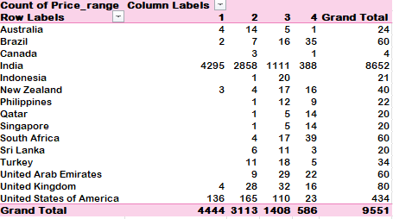

Insights:

Distribution of Restaurants by Price Range Across Countries
- India clearly leads the dataset as the largest market, with more than 85% of its restaurants falling into the low to medium price categories (ranges 1 and 2). This shows that affordable dining options are especially popular among Indian consumers.
- Meanwhile, the USA, UAE, and South Africa have a more even spread across price ranges, but their restaurants tend to cluster around ranges 2 and 3. This suggests that diners in these countries prefer a mix of budget and mid-tier options.
- In Australia, the UK, Singapore, and Canada, mid-to-premium restaurants (ranges from 3-4) are more common than budget ones. This likely reflects a customer base with higher spending power or a greater demand for upscale dining experiences.
- Finally, countries like Qatar, Turkey, and Indonesia have only a handful of restaurants represented in the dataset. Most of these are in the higher price brackets, which could indicate untapped opportunities or small but specialized markets.

Visualisation Techniques Used:
• ‘100% Stacked Column Chart’ was used to compare restaurant distribution across price ranges in different countries.
• ‘Combo Chart of Bar and Line Chart’ was used to compare Count of Restaurants and Average Ratings by Price Range.
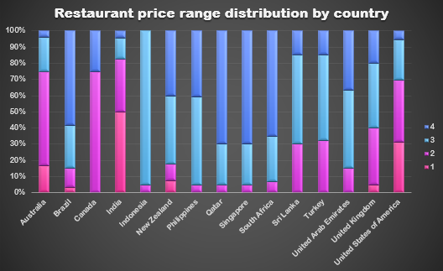
Distribution of Restaurants by Price Range Across Countries

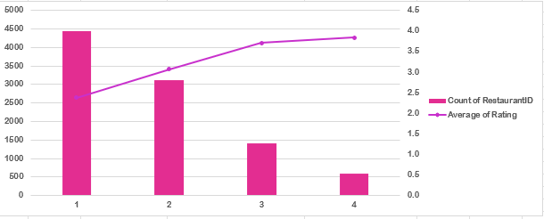
Relationship Between Price Range and Ratings
Image From ‘Subjective Answer 9.’ Worksheet in Excel Sheet

Suggestions:
- In India and Brazil, Zomato could really connect with budget-friendly restaurants by:
- Launching combos, loyalty programs, simple affordability filters, and price-focused campaigns.
- For people in the USA, UAE, UK, and Australia.
- Highlight premium listings with quality tags and chef’s specials, and offer premium memberships including reservations and exclusive deals.
- And in places where Zomato isn’t as well-known, such as Indonesia, Qatar, or Sri Lanka
- Start by testing locally, partnering with restaurants, and running pilots to determine effective pricing.

- Explain your approach in brief for suggesting countries/cities in order to open new restaurants, if the objective and subjective questions would have not been given to assist you. [you have to give bullet pointers in order to answer this question]

Answer:
Approach for Suggesting Countries and Cities for Opening New Restaurants
• Analysed countries based on average restaurant ratings to identify markets with good customer satisfaction and dining quality.
• Focused on countries having fewer restaurants, which indicates lower competition and better expansion opportunities.
• Considered average customer votes to identify countries with higher customer engagement and active food markets.
• Evaluated the average cost for two people to understand customer spending capacity and possible revenue generation.
• Shortlisted cities within selected countries based on demand, competition level, customer ratings, and affordability.
• Preferred cities with high customer demand but comparatively lower restaurant competition.
• Analysed cuisine preferences in shortlisted cities to understand local food trends and customer interests.
• Identified cuisines with higher ratings and strong customer demand to improve the chances of restaurant success.
• Considered online delivery and table booking availability to evaluate digital service opportunities and customer convenience.
• Analysed customer ratings across price ranges to understand which pricing categories perform better in different countries.
• Examined premium and budget dining trends to identify suitable restaurant positioning strategies.
• Used Pivot Tables, Charts, and Data Visualisation techniques for comparative analysis and better decision-making.
• Final recommendations were based on a combination of:
- High customer demand
- Good average ratings
- Lower competition
- Revenue potential
- Cuisine popularity
- Customer engagement
- Market growth opportunities

